## Introduction:-

The project is constructed by Aryapratik,Aashirbad, Ansh, and Sahil focused on the development of an Apna Ghar webpage . The objective was to create a user-friendly interface using prominent web technologies like HTML5, CSS, and JavaScript. This report is the collaborative efforts and outcomes achieved during the project's execution.

"Apna Ghar" is a revolutionary online platform dedicated to simplifying the process of buying and selling houses. This user-friendly webpage serves as a comprehensive marketplace, connecting potential homebuyers with sellers in a seamless and efficient manner. Whether you're in search of your dream home or looking to sell your property, Apna Ghar offers a one-stop solution for all your real estate needs.

Key Features:

1. **User-Friendly Interface:** Apna Ghar boasts an intuitive and easy-to-navigate interface, ensuring a hassle-free experience for both buyers and sellers. The platform is designed to provide a smooth and enjoyable journey through the entire real estate transaction process.
2. **Property Listings:** Sellers can create detailed property listings, showcasing their homes with high-quality images, accurate descriptions, and essential details. This allows buyers to make informed decisions and explore a wide range of options tailored to their preferences.
3. **Advanced Search Filters:** Apna Ghar's advanced search filters enable users to narrow down their choices based on specific criteria such as location, budget, number of bedrooms, and more. This ensures that buyers find homes that match their unique requirements.
4. **Virtual Tours:** To enhance the virtual experience, Apna Ghar incorporates virtual tours of listed properties. Prospective buyers can explore homes from the comfort of their own space, providing a realistic and immersive feel of the property before scheduling a physical visit.
5. **Secure Transactions:** The platform prioritizes the security of transactions, providing a reliable and trustworthy environment for both buyers and sellers. Apna Ghar employs robust encryption and authentication measures to safeguard financial transactions and personal information.
6. **Community and Neighborhood Information:** Apna Ghar goes beyond just listing properties. It provides valuable insights into the surrounding communities and neighborhoods, helping buyers make well-informed decisions about the location they are interested in.
7. **Responsive Customer Support:** A dedicated customer support team is available to assist users with any queries or concerns they may have. Whether it's technical support, guidance on the buying/selling process, or general assistance, Apna Ghar is committed to providing excellent customer service.

**Technologies Used:-**

The successful development of the Apna Ghar website's frontend relied on a meticulous selection and utilization of cutting-edge web technologies. The integration of HTML5, CSS, and JavaScript formed the bedrock of our project, empowering us to create a robust, visually appealing, and interactive user interface.

**HTML5 - Structuring Content**

HTML5, as the core markup language, provided the structural foundation for the website. Leveraging its advanced features, we ensured semantic structuring and accessibility compliance, thereby enhancing the website's overall usability. Its elements facilitated a well-organized representation of content, optimizing search engine indexing and improving user navigation.

**CSS - Design and Styling**

Cascading Style Sheets (CSS) were instrumental in elevating the visual appeal of the website. Through CSS, we meticulously designed and stylized the interface, ensuring consistency, responsiveness, and aesthetic coherence across various devices and screen sizes. The use of CSS frameworks and methodologies streamlined our styling process, enabling efficient management and scalability of stylesheets.

**JavaScript - Interactivity and Functionality**

JavaScript served as the backbone for interactivity and enhanced functionality. Leveraging its dynamic capabilities, we implemented features that enriched user engagement, such as interactive product displays, real-time updates in the shopping cart, and seamless navigation. JavaScript frameworks and libraries augmented our development process, enabling the creation of a responsive and interactive user experience.

MODULES:-

1. CSS Styling:

• The code uses inline CSS styling within HTML elements, providing a quick and straightforward way to apply styling to specific elements.

• Advantages: Inline styling is easy to implement and allows for direct control over individual elements. However, for larger projects, an external stylesheet might be preferred for better organization and maintainability.

2. JavaScript:

• JavaScript is used for interactive features and dynamic behavior.

• openLogIn() function is called when the "Log In/Sign Up" button is clicked, presumably opening a login modal or redirecting to a login page.

• showMessage() function is called when the "Post Property" button is clicked, possibly displaying a message or initiating a property posting action.

• Advantages: JavaScript adds interactivity to the webpage, making it more user-friendly. It can handle events, manipulate the DOM, and enable asynchronous communication with the server.

3. Ionicons:

• Ionicons is a popular icon library used for including vector icons in the HTML page.

• The script tags at the end of the document load the Ionicons module.

• Advantages: Ionicons provides a wide variety of icons that can enhance the visual appeal of the website. It is easy to use and customizable.

4. Form Handling:

• The HTML includes a form for property search with various input fields such as search, category selection, minimum and maximum price, and a submit button.

• Advantages: Forms are essential for user interaction. The form likely submits data to the server for processing, such as fetching search results based on user input.

5. File Upload Form:

• A form is provided for users to upload property images with an associated "Post Property" button.

• Advantages: This allows users to submit images related to their property, enhancing the property listing. File uploads can be handled server-side to store images.

6. Sections and Divs:

• The HTML is organized into various sections, such as "background," "container1," "advertise," etc.

• Advantages: Properly organizing HTML content into sections and divs enhances readability and makes it easier to apply styling and structure the layout.

7. Accessibility Considerations:

• Some elements include aria-label attributes, enhancing accessibility for users with disabilities.

• Advantages: Adding ARIA attributes improves the accessibility of the webpage by providing additional information to assistive technologies.

8. External Libraries:

• The HTML imports the Ionicons library using the <script> tag with the type="module" attribute.

• Advantages: External libraries like Ionicons provide pre-built functionality, reducing the need to write custom code for common features. They are easy to integrate and can save development time.

In summary, the provided HTML code employs various modules and practices to create an interactive and visually appealing webpage for a real estate platform. These modules contribute to the overall functionality, styling, and user experience of the website.

## Products Section:-

1. **Container and Navigation:**
   * The product section is encapsulated within a **<div>** with the class "container1."
   * It includes a navigation bar (**<div class="navbar2 space1" id="nav2">**) with links to different sections such as Home, Contact, Sell, Rent, Buy, and a "Log In/Sign Up" button.
2. **Title:**
   * A title is displayed within the container: "Get Started With Exploring Different Properties !!!"
3. **Search Panel:**
   * The search panel consists of a form (**<form action="" class="hero-form">**) with several input elements for property search.
   * Users can input search terms, select property categories (House, Apartment, Offices, Townhome), and set minimum and maximum price ranges.
   * The form includes a "Search now" button to initiate the search.
4. **Option Bar:**
   * Below the search panel, there is an option bar with three distinct sections for buying, selling, and renting properties.
   * Each section includes a description (**<div class="option-bar">**) along with an associated image depicting the respective action.
5. **Background-About Section:**
   * A background section (**<div class="background-about">**) with the title "How It Works" provides information on the process of buying, selling, and renting properties.
   * It includes a series of cards with icons and descriptions detailing the steps: Evaluate Property, Meeting with Agent, and Close the Deal.
6. **Buy Section:**
   * A "Buy" section (**<div class="buy-section" id="buy">**) with the text "Buy From The Best Sellers Available" is presented, indicating a focus on facilitating property purchases.
7. **Buyer Section:**
   * A "buyer" section (**<div class="buyer">**) displays individual property cards with details such as property type, location, area, price, and rating.
   * Each property card includes an image, and there are multiple cards representing different properties available for purchase.
8. **Rent Section:**
   * A "Rent" section (**<div class="buy-section" id="rent">**) with the text "Rent Property According To Your Budget" emphasizes the availability of properties for rent.
9. **Renter Section:**
   * A "renter" section (**<div class="renter">**) displays property cards similar to the buyer section but with details relevant to rental properties.
10. **Sell Section:**
    * A "Sell" section (**<div class="buy-section" id="sell">**) with the text "Sell Property At A Valuable Price" encourages users to list their properties for sale.
11. **Background-About Section for Sellers:**
    * A second background section (**<div class="background-about1">**) titled "How Are Sellers Rated" provides information on the criteria for selecting sellers.
    * It includes cards with icons and descriptions related to seller ratings, such as High Response Rate, Wide Coverage, Deals Closed, and Rated & Reviewed.
12. **Seller Section:**
    * A "seller" section (**<div class="seller">**) showcases individual property cards representing satisfied sellers.
    * Each card includes an image and details about the seller, property type, location, and price.
13. **Upload Property Images:**
    * A section with the heading "Upload Your Property Images" (**<h3 class="sellhead">Upload Your Property Images :</h3>**) is provided.
    * A form allows users to upload property images with an associated "Post Property" button, which likely triggers the posting of the property listing.

These pointers outline the key components and features of the product section in the provided HTML code, showcasing the platform's focus on buying, selling, and renting properties.

## Overall:

1. **Header Section:**
   * Contains a navigation bar with links to different sections (Home, Contact, Sell, Rent, Buy) and a "Log In/Sign Up" button.
   * Displays the website logo and an introductory message.
2. **Main Content:**
   * Divided into various sections within a **<main>** tag.
   * **Container1 Section:**
     + Title: "Get Started With Exploring Different Properties !!!"
     + Search panel with form elements for property search (buy, sell, rent).
     + Option bar with sections for buying, selling, and renting properties.
   * **Background-About Section:**
     + Describes how the platform works, including evaluating properties, meeting with agents, and closing deals.
   * **Buy Section:**
     + Promotes buying properties with the text "Buy From The Best Sellers Available."
   * **Buyer Section:**
     + Displays individual property cards for buyers, showcasing details such as property type, location, area, price, and rating.
   * **Rent Section:**
     + Promotes renting properties with the text "Rent Property According To Your Budget."
   * **Renter Section:**
     + Displays property cards for rental properties similar to the buyer section.
   * **Sell Section:**
     + Encourages users to sell their properties with the text "Sell Property At A Valuable Price."
   * **Background-About Section for Sellers:**
     + Provides information on how sellers are rated based on criteria such as response rate, coverage, deals closed, and ratings/reviews.
   * **Seller Section:**
     + Showcases individual property cards for sellers, including details about the seller, property type, location, and price.
   * **Upload Property Images Section:**
     + Allows users to upload property images with a form and a "Post Property" button.
3. **Footer:**
   * Includes a footer section with links, information, and copyright details.
   * Divided into grids with categories such as "People Also Search For," "City Collections," and "Filter Your Search."
4. **External Dependencies:**
   * Includes the Ionicons library for displaying vector icons.
   * Uses JavaScript for interactive features, such as opening the login modal and handling property posting.
5. **Accessibility Considerations:**
   * Some elements include **aria-label** attributes to enhance accessibility.
6. **Styling:**
   * Utilizes inline CSS for styling elements within the HTML.
7. **File Upload Form:**
   * Provides a form for users to upload property images.

These pointers provide an overview of the different sections and functionalities present in the HTML code, giving a comprehensive understanding of the webpage structure.

# WEBSITE SCREENSHOTS & CODE

# This is the homepage of the webpage.

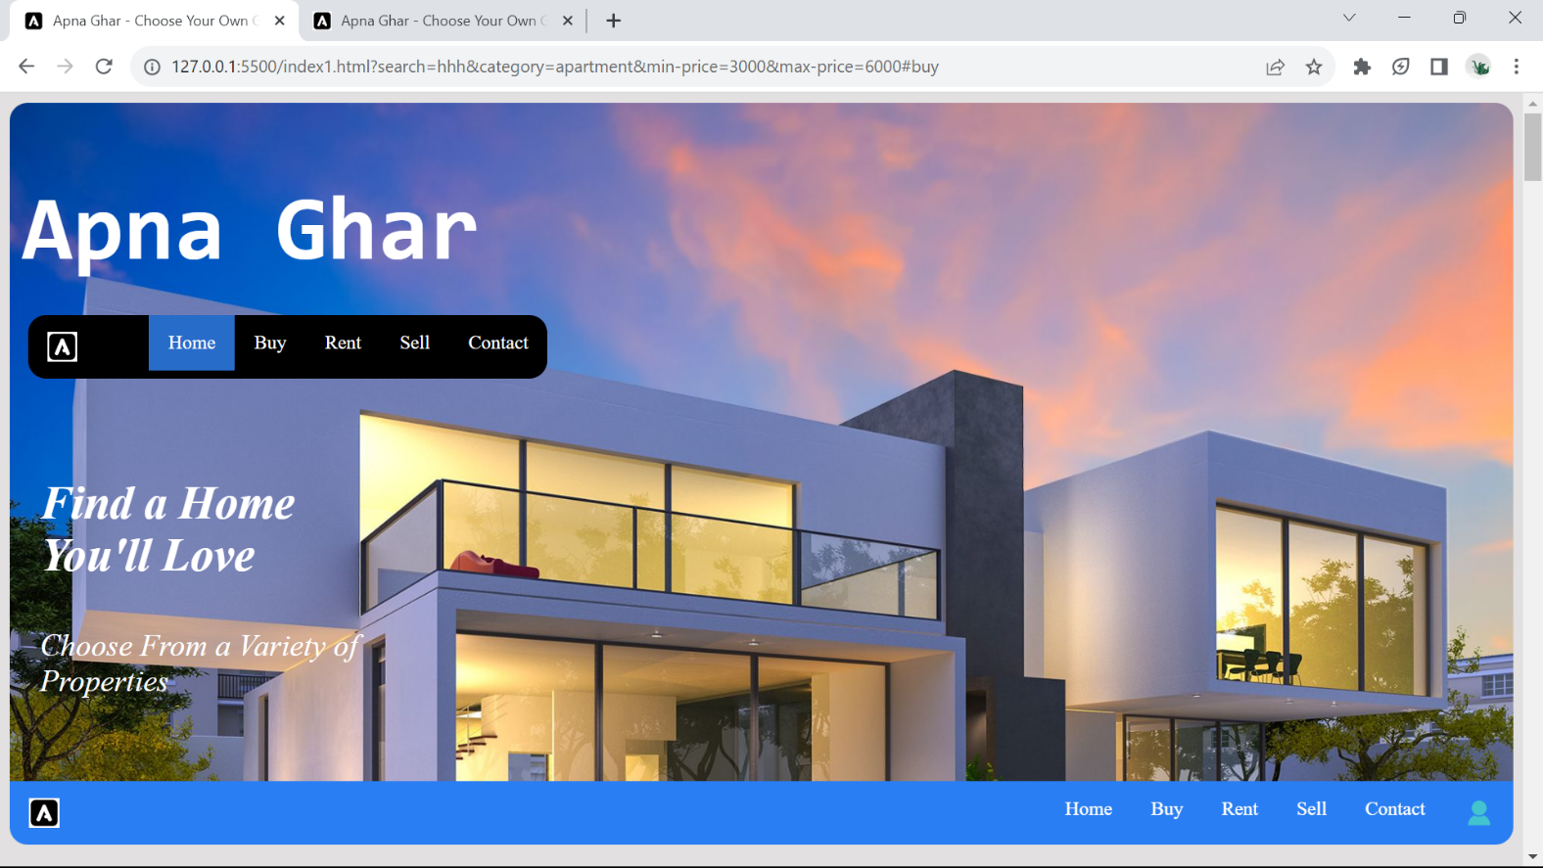

**Code is given below.**

 <div class="background" id="home">

        <div>

            <button type="button" class="login-button" onclick="openLogIn()">Log In/ Sign Up</button>

        </div>

        <header>

            <h1 style="margin-top: 53.456px;margin-bottom: 22.456px;">Apna Ghar</h1>

        </header>

        <div class="navbar" style="margin-left: 15px;">

            <ul>

                <li style="float: left;"><a rel="noopener" href="#home"><img src="/images/favicon/favicon1.ico"

                            height="25px" alt="favicon"></a></li>

                <li><a href="/contact.html">Contact</a></li>

                <li><a href="#sell">Sell</a></li>

                <li><a href="#rent">Rent</a></li>

                <li><a href="#buy">Buy</a></li>

                <li><a class="active" href="#home">Home</a></li>

            </ul>

            <br>

        </div>

        <div class="advertise">

            <p class="p1">Find a Home You'll Love</p>

            <p class="p2">Choose From a Variety of Properties</p>

        </div>

        <br><br>

    </div>

    <main>

        <div class="container1">

            <div class="navbar2 space1" id="nav2">

                <ul>

                    <li style="float: left;"><a rel="noopener" href="#home"><img src="/images/favicon/favicon1.ico"

                                height="25px" alt="favicon"></a></li>

                    <li onclick="openLogIn()"><a href="#Home">Log In/ Sign Up</a></l1>

                    <li><a href="/contact.html">Contact</a></li>

                    <li><a href="#sell">Sell</a></li>

                    <li><a href="#rent">Rent</a></li>

                    <li><a href="#buy">Buy</a></li>

                    <li><a href="#home">Home</a></li>

                </ul>

            </div>

            <div class="title">

                <p>Get Started With Exploring Different Properties !!!</p>

            </div>

**By this section user can search for his/her desire house**

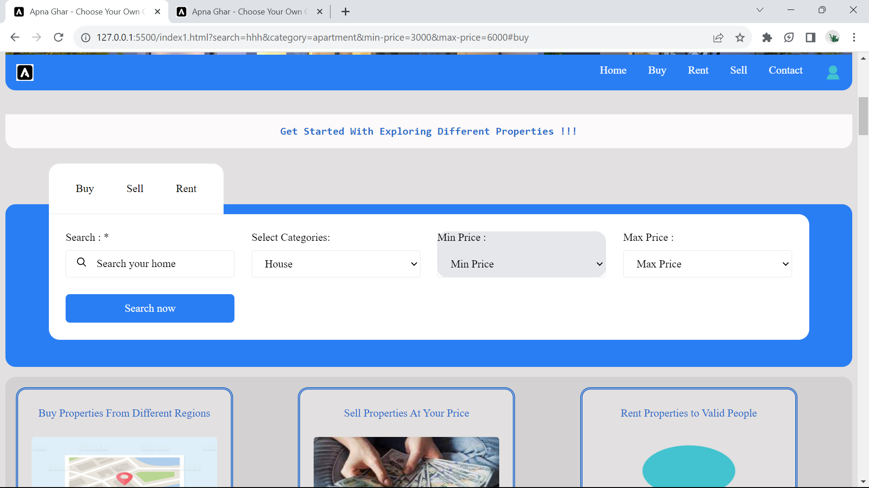

**Code is given below.**

<div class="title">

                <p>Get Started With Exploring Different Properties !!!</p>

            </div>

            <br><br>

            <div class="searchpanel">

                <article class="article">

                    <section class="section hero" aria-label="hero">

                        <div class="container">

                            <div class="hero-form-wrapper">

                                <div class="form-tab">

                                    <button type="button" class="tab-btn" data-tab-btn>Buy</button>

                                    <button type="button" class="tab-btn" data-tab-btn>Sell</button>

                                    <button type="button" class="tab-btn" data-tab-btn>Rent</button>

                                </div>

                                <form action="" class="hero-form">

                                    <div class="input-wrapper">

                                        <label for="search" class="input-label">Search : *</label>

                                        <input type="search" name="search" id="search" placeholder="Search your home"

                                            required class="input-field">

                                        <ion-icon name="search-outline"></ion-icon>

                                    </div>

                                    <div class="input-wrapper">

                                        <label for="category" class="input-label">Select Categories:</label>

                                        <select name="category" id="category" class="dropdown-list">

                                            <option value="house">House</option>

                                            <option value="apartment">Apartment</option>

                                            <option value="offices">Offices</option>

                                            <option value="townhome">Townhome</option>

                                        </select>

                                    </div>

                                    <div class="input-wrapper">

                                        <label for="min-price" class="input-label">Min Price :</label>

                                        <select name="min-price" id="min-price" class="dropdown-list">

                                            <option value="min price">Min Price</option>

                                            <option value="500">10000</option>

                                            <option value="1000">50000</option>

                                            <option value="2000">100000</option>

                                            <option value="3000">500000</option>

                                            <option value="4000">1000000</option>

                                            <option value="5000">5000000</option>

                                            <option value="6000">10000000</option>

                                        </select>

                                    </div>

                                    <div class="input-wrapper">

                                        <label for="max-price" class="input-label">Max Price :</label>

                                        <select name="max-price" id="max-price" class="dropdown-list">

                                            <option value="max price">Max Price</option>

                                            <option value="1000">50000</option>

                                            <option value="2000">100000</option>

                                            <option value="3000">500000</option>

                                            <option value="4000">1000000</option>

                                            <option value="5000">5000000</option>

                                            <option value="6000">10000000</option>

                                            <option value="6000">50000000</option>

                                        </select>

                                    </div>

                                    <button type="submit" class="btn btn-primary">Search now</button>

                                </form>

                            </div>

                        </div>

                    </section>

                </article>

            </div>

**How the website work is mentioned below..**

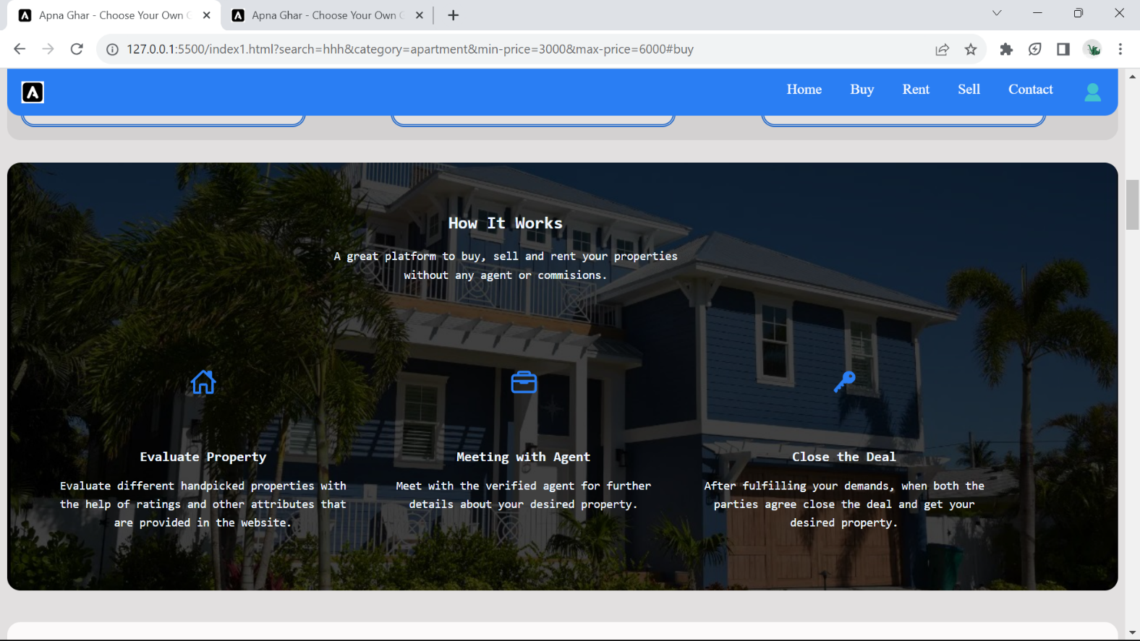

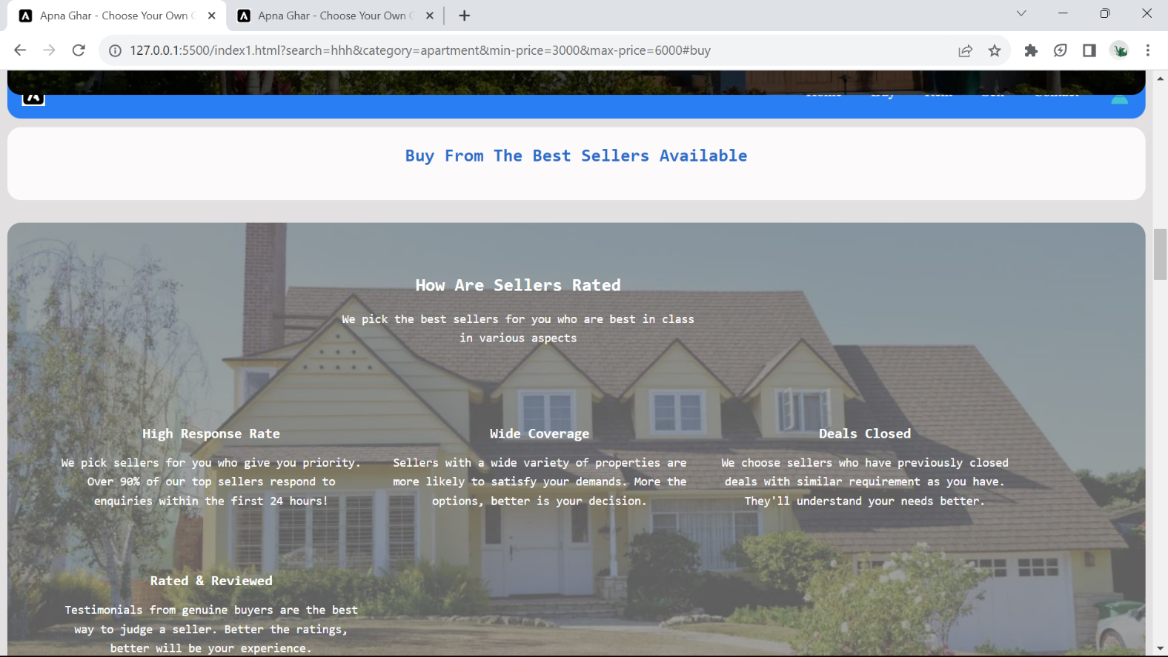

**Code is given below.**

<div class="background-about">

                <section class="section service" aria-label="service">

                    <div class="container">

                        <h2 class="h2 section-title">How It Works</h2>

                        <p class="section-text">

                            A great platform to buy, sell and rent your properties without any agent or commisions.

                        </p>

                        <ul class="service-list">

                            <li>

                                <div class="service-card">

                                    <div class="card-icon">

                                        <ion-icon name="home-outline"></ion-icon>

                                    </div>

                                    <h3 class="h3 card-title">Evaluate Property</h3>

                                    <p class="card-text">

                                        Evaluate different handpicked properties with the help of ratings and other

                                        attributes that are provided in the website.

                                    </p>

                                </div>

                            </li>

                            <li>

                                <div class="service-card">

                                    <div class="card-icon">

                                        <ion-icon name="briefcase-outline"></ion-icon>

                                    </div>

                                    <h3 class="h3 card-title">Meeting with Agent</h3>

                                    <p class="card-text">

                                        Meet with the verified agent for further details about your desired property.

                                    </p>

                                </div>

                            </li>

                            <li>

                                <div class="service-card">

                                    <div class="card-icon">

                                        <ion-icon name="key"></ion-icon>

                                    </div>

                                    <h3 class="h3 card-title">Close the Deal</h3>

                                    <p class="card-text">

                                        After fulfilling your demands, when both the parties agree close the deal and

                                        get your desired property.

                                    </p>

                                </div>

                            </li>

                        </ul>

                    </div>

                </section>

            </div>

**This is the buyer class of the website**

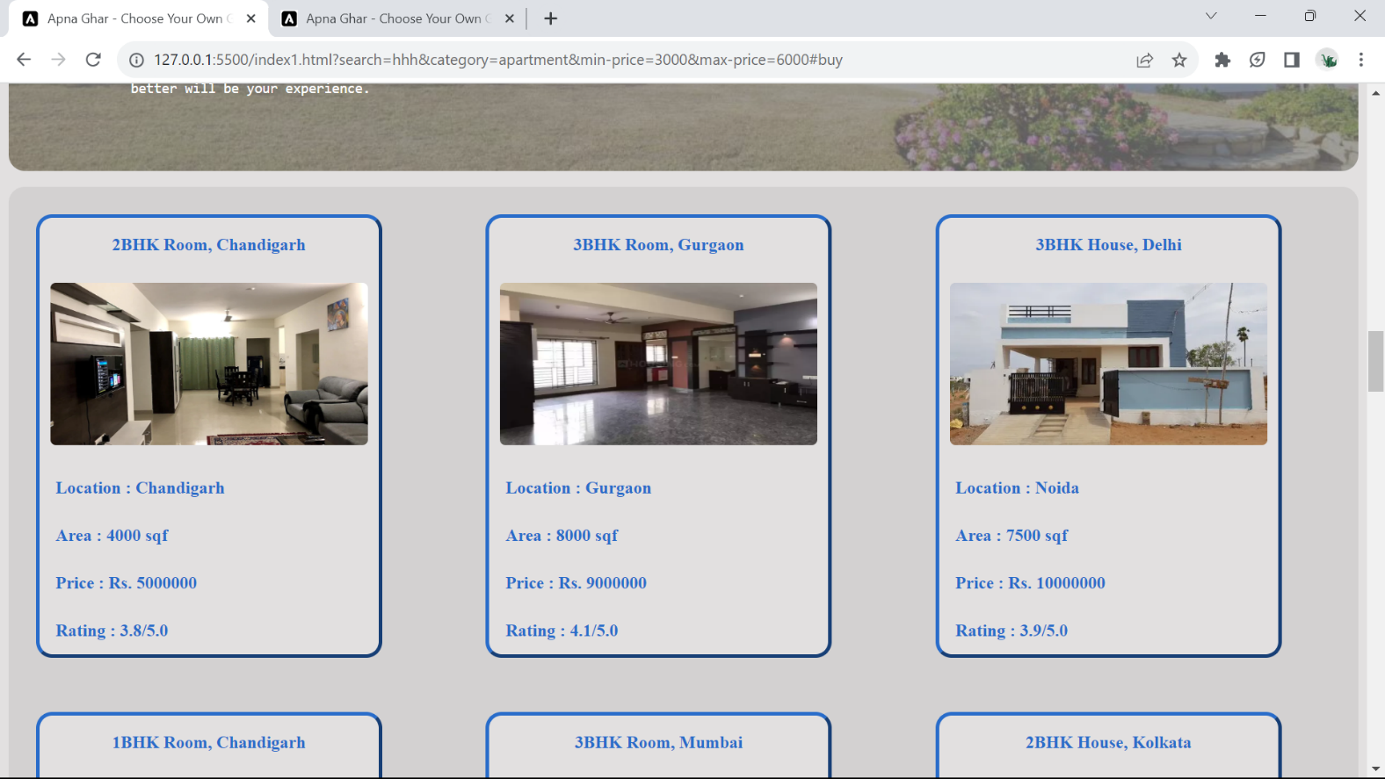

**Code is given below.**

            <div class="buyer">

                <div class="property prop1">

                    <p class="para-head">2BHK Room, Chandigarh</p>

                    <img src="/images/property images/property19.webp" alt="property prop19">

                    <p class="para-card">Location : Chandigarh</p>

                    <p class="para-card">Area : 4000 sqf</p>

                    <p class="para-card">Price : Rs. 5000000</p>

                    <p class="para-card">Rating : 3.8/5.0</p>

                </div>

                <div class="property prop2">

                    <p class="para-head">3BHK Room, Gurgaon</p>

                    <img src="/images/property images/property20.webp" alt="property prop20">

                    <p class="para-card">Location : Gurgaon</p>

                    <p class="para-card">Area : 8000 sqf</p>

                    <p class="para-card">Price : Rs. 9000000</p>

                    <p class="para-card">Rating : 4.1/5.0</p>

                </div>

                <div class="property prop3">

                    <p class="para-head">3BHK House, Delhi</p>

                    <img src="/images/property images/property21.webp" alt="property prop21">

                    <p class="para-card">Location : Noida</p>

                    <p class="para-card">Area : 7500 sqf</p>

                    <p class="para-card">Price : Rs. 10000000</p>

                    <p class="para-card">Rating : 3.9/5.0</p>

                </div>

**This is the Rent class of the website**

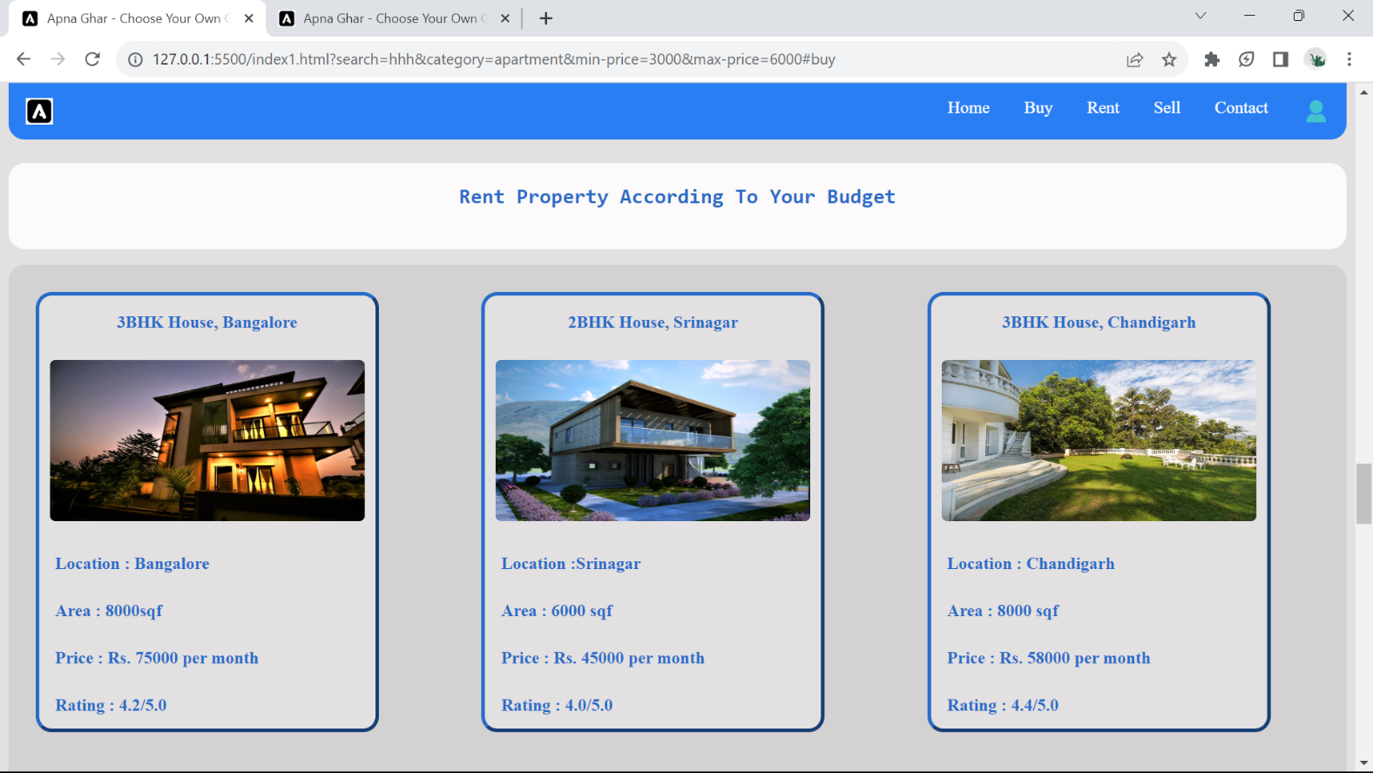

**Code is given below.**

 <div class="renter">

                <div class="property prop1">

                    <p class="para-head">3BHK House, Bangalore</p>

                    <img src="/images/property images/property10.webp" alt="property prop10">

                    <p class="para-card">Location : Bangalore</p>

                    <p class="para-card">Area : 8000sqf</p>

                    <p class="para-card">Price : Rs. 75000 per month</p>

                    <p class="para-card">Rating : 4.2/5.0</p>

                </div>

                <div class="property prop2">

                    <p class="para-head">2BHK House, Srinagar</p>

                    <img src="/images/property images/prorperty11.webp" alt="property prop11">

                    <p class="para-card">Location :Srinagar</p>

                    <p class="para-card">Area : 6000 sqf</p>

                    <p class="para-card">Price : Rs. 45000 per month</p>

                    <p class="para-card">Rating : 4.0/5.0</p>

                </div>

                <div class="property prop3">

                    <p class="para-head">3BHK House, Chandigarh</p>

                    <img src="/images/property images/property12.jpg" alt="property prop12">

                    <p class="para-card">Location : Chandigarh</p>

                    <p class="para-card">Area : 8000 sqf</p>

                    <p class="para-card">Price : Rs. 58000 per month</p>

                    <p class="para-card">Rating : 4.4/5.0</p>

                </div>

**For selling property**

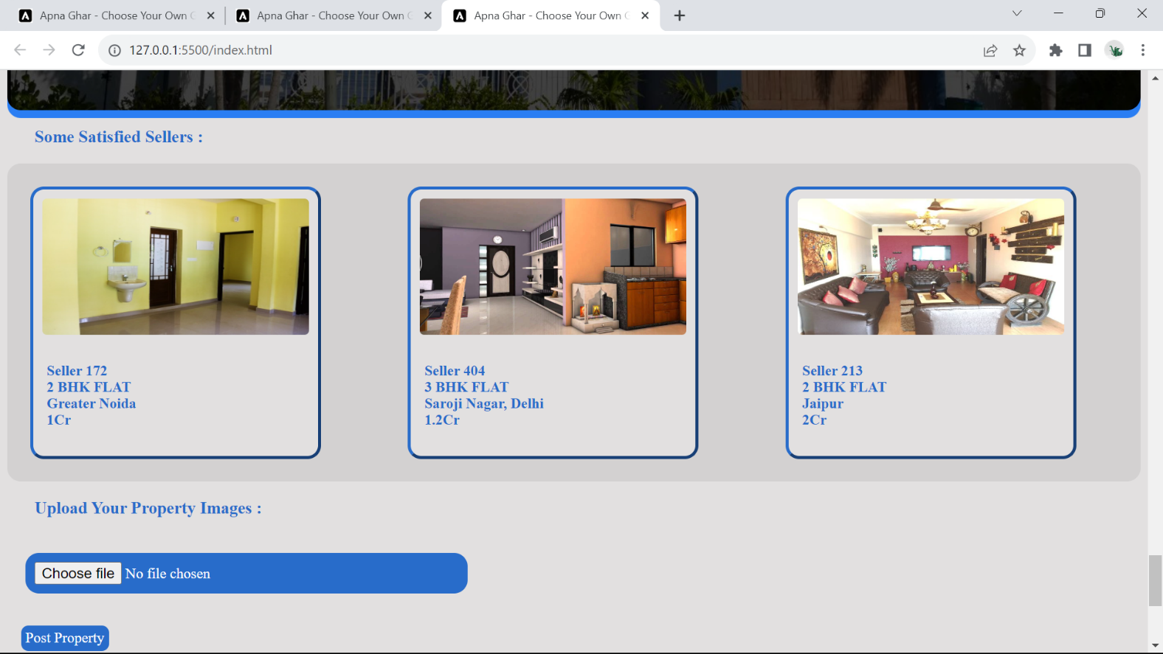

**Code is given below.**

 <h3 class="sellhead">Some Satisfied Sellers :</h3>

            <div class="seller">

                <div class="property prop1 clsell">

                    <img src="/images/property images/property1.jpg" alt="Property prop1">

                    <p class="para-card">

                        Seller 172<br>

                        2 BHK FLAT<br>

                        Greater Noida<br>

                        1Cr

                    </p>

                </div>

                <div class="property prop2 clsell">

                    <img src="/images/property images/property2.jpg" alt="property prop2">

                    <p class="para-card">

                        Seller 404<br>

                        3 BHK FLAT <br>

                        Saroji Nagar, Delhi<br>

                        1.2Cr

                    </p>

                </div>

                <div class="property prop3 clsell">

                    <img src="/images/property images/property3.jpg" alt="property prop3">

                    <p class="para-card">

                        Seller 213<br>

                        2 BHK FLAT<br>

                        Jaipur<br>

                        2Cr

                    </p>

                </div>

            </div>

        </div>

        <h3 class="sellhead">Upload Your Property Images :</h3>

        <form id="pform" action="">

            <input type="file" id="myFile" name="filename">

            <button id="pbutton" type="button" onclick="showMessage()">Post Property</button>

        </form>

**Footer section**

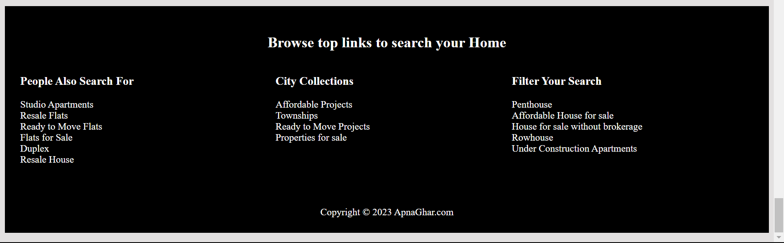

**Code is given below.**

<footer class="index-foot">

        <h2>Browse top links to search your Home</h2>

        <div class="foot-grid">

            <div class="foot-grid1">

                <h3 class="fh">People Also Search For</h3>

                <p class="fp">Studio Apartments<br>

                    Resale Flats<br>

                    Ready to Move Flats<br>

                    Flats for Sale<br>

                    Duplex<br>

                    Resale House</p>

                <br>

                <br>

            </div>

            <div class="foot-grid2">

                <h3 class="fh">City Collections</h3>

                <p class="fp">Affordable Projects<br>

                    Townships<br>

                    Ready to Move Projects<br>

                    Properties for sale</p>

                <br>

                <br>

            </div>

            <div class="foot-grid3">

                <h3 class="fh">Filter Your Search</h3>

                <p class="fp">Penthouse<br>

                    Affordable House for sale<br>

                    House for sale without brokerage<br>

                    Rowhouse<br>

                    Under Construction Apartments</p>

                <br>

                <br>

            </div>

        </div>

        <p id="cop">Copyright &copy; 2023 ApnaGhar.com</p>

    </footer>

    <script type="module" src="https://unpkg.com/ionicons@5.5.2/dist/ionicons/ionicons.esm.js"></script>

    <script nomodule src="https://unpkg.com/ionicons@5.5.2/dist/ionicons/ionicons.js"></script>

**REFERENCES:-**

1. Various images were taken from Pinterest.
2. All the banner images were taken from Google. 3). Icons were imported from Font Awesome.

4). Some were taken from Github.